PRESS RELEASE

COMMUNICATIONS AND MEDIA TEAM OF THE 43RD ASEAN SUMMIT 2023

No.123/SP/TKM-ASEAN2023/ENG/9/2023

Indonesia’s Ceramic Draws ASEAN Summit Delegates’ Attention

JAKARTA, 9 September 2023 - Rows of beautiful ceramic glasses adorned with Jakarta's iconic Ondel-Ondel (giant Betawi effigies) and Monas Monument motifs are neatly displayed at the Jinjit Pottery booth. There are also ceramic glasses with adorable cat motifs. Several visitors were seemed captivated by these unique ceramics crafted by artist Antin Sambodo.

On that afternoon, Antin, who once worked as an architect, participated in the ASEAN Weekend Market exhibition held at the Senayan Multipurpose Building from 1 – 3 September 2023. Jinjit Pottery is one of the 45 micro, small, and medium-sized enterprises (MSMEs) from ASEAN countries participating in the event.

Antin's interest in ceramic art began during the Indonesian financial crisis in 1998. As an architect, she struggled to find a job due to the economic downturn. She then decided to learn ceramic art. Surprisingly, her newfound skill made her fall in love with it. In 2000, she took the bold step of starting Jinjit Pottery with an initial capital of Rp15 million.

"I started learning ceramics back then and became interested. It's a medium I can explore because it has artistry, similar to architecture," she said when interviewed during the exhibition by the 43rd ASEAN Summit Communication and Media Team on Sunday, 7 September 2023.

Her vision, as a woman who loves to travel, is simple: to bring happiness to others through her creations. All ceramic products launched by Jinjit Pottery are made with dedication. "I make what I like. So, all my ceramic creations have their 'soul'," she added.

One thing that makes her products unique is the themes she releases, such as cats and Jakarta. Why the cat theme? Because Antin is a cat lover. As for the Jakarta theme, it was initially suggested by a friend when she was selling Jinjit Pottery products at Sarinah in 2001.

"My products was on display at at Sarinah, and someone suggested that I make Jakarta souvenirs, which became bestsellers. There were magnets, mugs, and hanging chimes. They were beloved by many foreigners. After a while, I stopped making them, but I'm starting up again because there are more events," Antin said.

It was the cat theme that allowed her ceramic business to survive the COVID-19 pandemic. Initially, there was a decrease in revenue due to the lack of exhibitions. However, Antin didn't give up. She innovated by creating unique designs, such as cat-themed tableware with masks, to remind people of the importance of adhering to health protocols during the pandemic.

"Even cats wear masks; so why not you? It's also a reminder that we’ve been through a pandemic. It turns out many people liked them, and they sold like hotcakes," said Antin, who markets her ceramic products with prices ranging from Rp50,000 to Rp350,000.

Ceramic glasses with Jakarta's Ondel-Ondel and Monas Monument motifs are indeed popular among ASEAN delegates, including those from the Philippines and Cambodia. They even bought Antin's products to use as distinctive souvenirs from Indonesia.

Additionally, there were buyers from Indonesia as well. One of them was Mira (42), who purchased aromatherapy candles. "I bought these candles because they have unique Jakarta-themed Ondel-Ondel motifs. These are souvenirs for my Indian friend who is returning to his country," Mira said.

Antin hopes that by participating in the ASEAN Weekend Market, Indonesian-made ceramic products can gain recognition internationally, thereby opening up broader opportunities and markets for Jinjit Pottery.

"Hopefully, Hopefully, this will allow us to establish new networking with ASEAN countries, with whom we have not previously had a relationship," she added.

The event, initiated by the Indonesian Chamber of Commerce and Industry (Kadin) in collaboration with the ASEAN Business Advisory Council (ASEAN-BAC), aims to boost the performance of MSMEs from ASEAN countries.

Arsjad Rasjid, the Chairman of Kadin Indonesia and Chairman of ASEAN-BAC, hopes that business owners can promote their products while exploring potential collaborations with each other. (Angelina Donna/Elvira Inda Sari)

For more information, please contact:
Director General of Public Information and Communications of the Ministry of Communications and Informatics – Usman Kansong (0816785320).

Get more information at http://asean2023.id, https://infopublik.id/kategori/asean-2023, and https://indonesia.go.id/kategori/ragam-asean-2023

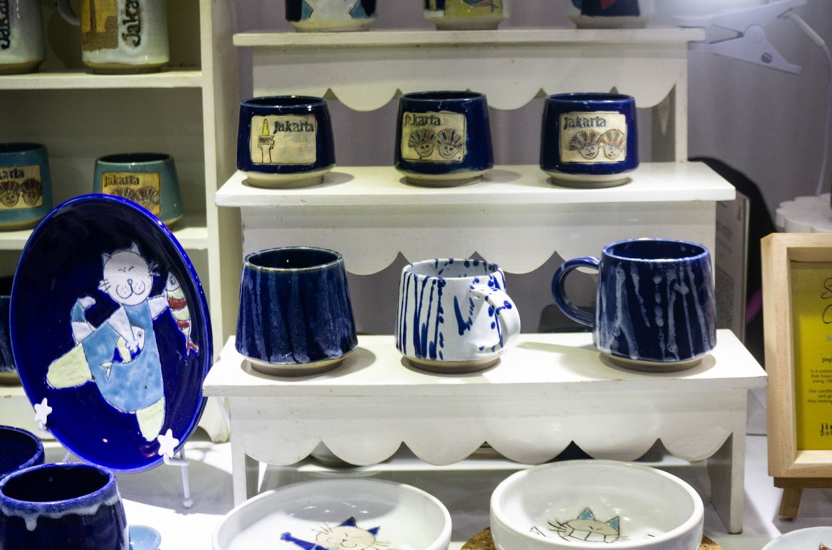

The ceramic products from Jinjit Pottery showcased at the ASEAN Weekend Market 2023 on 1 – 3 September 2023, at the Senayan Multipurpose Building, Jakarta. (Angelina Donna)

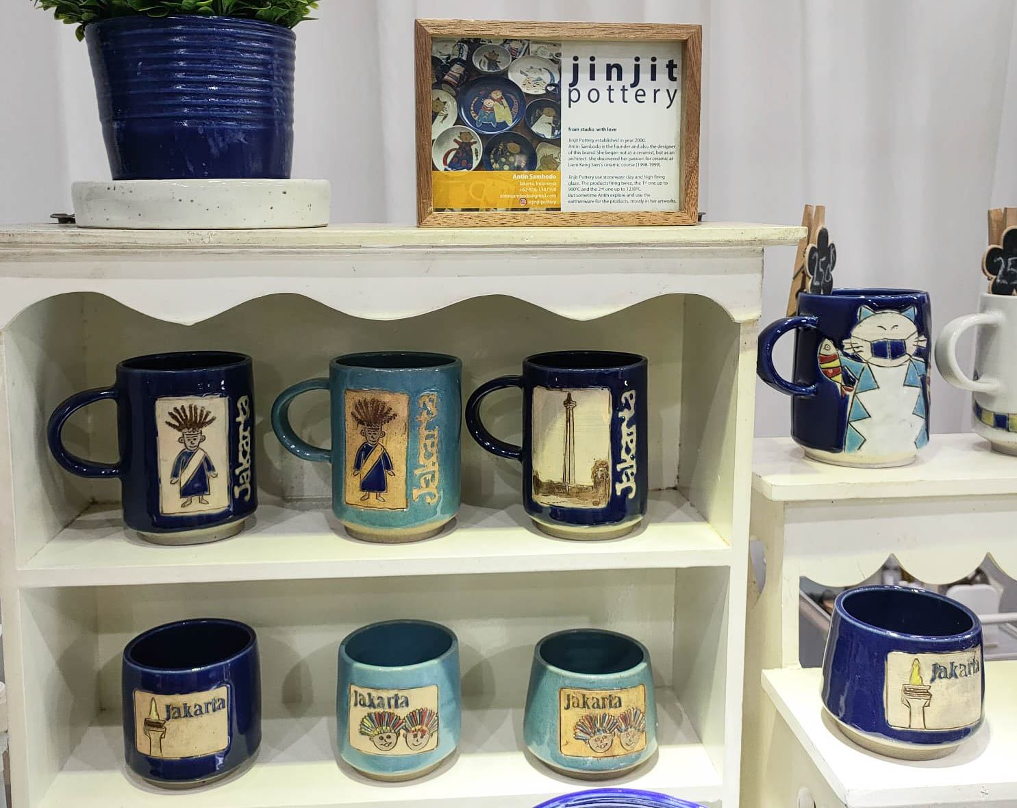

Jinjit Pottery's ceramic products with Jakarta-themed motifs are often bought as souvenirs by both foreign and domestic tourists. (Angelina Donna)

